Minor Project :AI Based Diabetes Prediction System

Submission Checklist:
Requirement | File
Full Source Code | train_model.py, app.py
Dataset | CSV dataset file from Kaggle / CDC BRFSS 2015
Interactive Web App | Patient form, BMI calculator, prediction output, risk factors, health tips, family history, performance tab, dataset tab(Streamlit)
Documentation | Dataset description, preprocessing, model training, evaluation metrics, embedded charts
Generated Files | model.pkl, scaler.pkl, feature_names.pkl, metrics.pkl
Plots | Confusion matrix, ROC curve, feature importance, heatmap, class distribution charts

Submitted by :
Thunga Sahithi Brunda

Introduction
AI-Based Diabetes Prediction System is a machine learning project which analyzes patient health data to predict the probability of diabetes. This system can be used to detect risk factors using supervised learning techniques, which can guide timely preventive measures and medical interventions by healthcare professionals and individuals. The system is constructed with a real-world survey data from the CDC (Centers for Disease Control and Prevention) collected in 2015 and fed into a Random Forest Classifier. The model categorizes patients as either Diabetic or Non-Diabetic, and gives them a risk score based on probability

1.1 Project Objectives
- Develop a binary classification model to predict diabetes (0 = Non-Diabetic, 1 = Diabetic)
- Apply data preprocessing, feature scaling, and model evaluation techniques
- Train and evaluate a Random Forest Classifier on real medical survey data
- Visualise patterns and correlations between health indicators
- Build an interactive Streamlit web application for real-time predictions

1.2 Technologies Used
Tool / Library | Purpose
Python 3 | Primary programming language
Pandas | Data loading and manipulation
NumPy | Numerical computations
Scikit-learn | Machine learning - model training, preprocessing, evaluation
Matplotlib / Seaborn | Data visualisation and plots
Streamlit | Interactive web application interface
Joblib | Saving and loading trained model files

2. Dataset Description
The dataset used in this project is the Diabetes Health Indicators Dataset derived from the CDC Behavioral Risk Factor Surveillance System (BRFSS) 2015 survey. It is publicly available on Kaggle and was compiled by Alex Teboul.

2.1 Dataset Overview
Property | Value
File Name | diabetes_binary_5050split_health_indicators_BRFSS2015.csv
Source | CDC BRFSS 2015 Survey (via Kaggle)
Total Rows | 70,692 samples
Total Features | 21 input features + 1 target column
Target Column | Diabetes_binary (0 = Non-Diabetic, 1 = Diabetic)
Class Balance | 50% Non-Diabetic (35,346),| 50% Diabetic (35,346)
Missing Values | None - dataset is complete with no null values
Data Type | All numerical (integer and float)

2.2 Class Distribution
One of the most common problems in medical datasets is class imbalance where one outcome (e.g. healthy) is far more common than the other (e.g. diabetic). This causes models to simply predict the majority class for every patient, achieving high accuracy but being clinically useless. The selected dataset solves this by providing an equal number of diabetic and non-diabetic samples, which forces the model to genuinely learn distinguishing patterns.

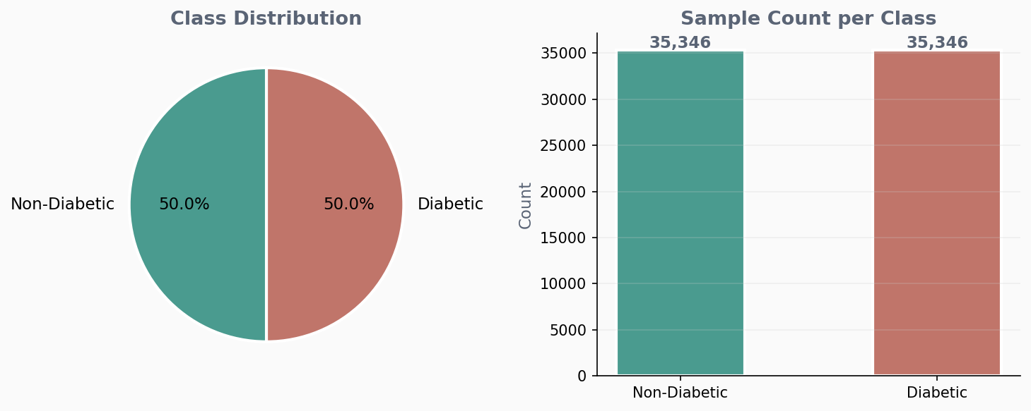
Figure 1: Class distribution - perfectly balanced with 35,346 samples per class

2.3 Feature Descriptions
The dataset contains 21 health-related features, all derived from the BRFSS survey responses. These features cover a broad range of health domains including cardiovascular indicators, lifestyle habits, healthcare access, and demographic information - making it a comprehensive profile of each individual.

Feature Name | Type | Description
HighBP | Binary | High blood pressure diagnosed (0=No, 1=Yes)
HighChol | Binary | High cholesterol diagnosed (0=No, 1=Yes)
CholCheck | Binary | Cholesterol check in last 5 years (0=No, 1=Yes)
BMI | Numeric | Body Mass Index - continuous value
Smoker | Binary | Smoked at least 100 cigarettes in lifetime
Stroke | Binary | Ever diagnosed with a stroke
HeartDiseaseorAttack | Binary | Coronary heart disease or heart attack history
PhysActivity | Binary | Physical activity in past 30 days (0=No, 1=Yes)
Fruits | Binary | Consumes fruit at least once per day
Veggies | Binary | Consumes vegetables at least once per day
HvyAlcoholConsump | Binary | Heavy alcohol consumption (men >14/wk, women >7/wk)
AnyHealthcare | Binary | Has any health care coverage
NoDocbcCost | Binary | Could not see a doctor in past year due to cost
GenHlth | Ordinal | General health self-rating (1=Excellent to 5=Poor)
MentHlth | Numeric | Days of poor mental health in past 30 days (0–30)
PhysHlth | Numeric | Days of poor physical health in past 30 days (0–30)
DiffWalk | Binary | Difficulty walking or climbing stairs
Sex | Binary | 0 = Female, 1 = Male
Age | Ordinal | Age group (1=18-24, 2=25-29, ..., 13=80+)
Education | Ordinal | Education level on a 1-6 scale
Income | Ordinal | Income level on a 1-8 scale

2.4 Correlation Analysis
Before training the model, it is important to understand how features relate to each other and to the target variable. The correlation heatmap below shows the Pearson correlation coefficient between every pair of columns. Values close to +1 indicate a strong positive relationship, values close to -1 indicate a strong negative relationship, and values near 0 indicate no linear relationship.

From the heatmap, the strongest predictors of diabetes are GenHlth (general health rating), BMI, Age, and HighBP. This aligns with well-established clinical knowledge poor general health, high body weight, older age, and high blood pressure are all recognised risk factors for Type 2 diabetes.

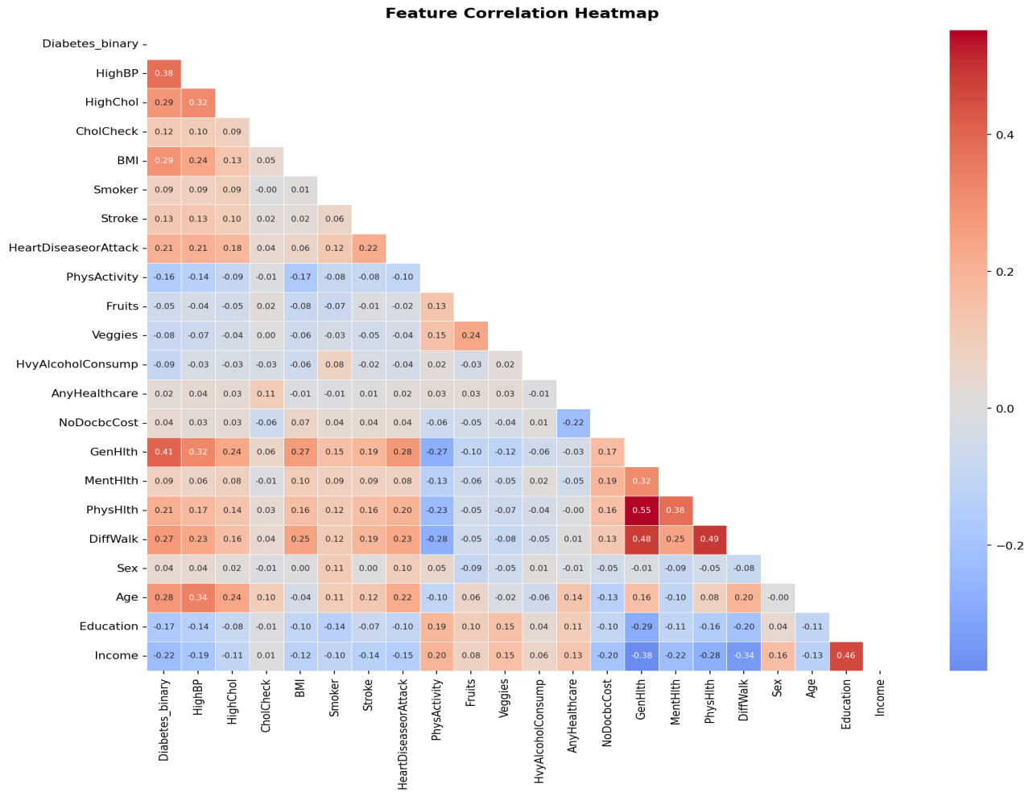
Figure 2: Feature correlation heatmap - darker red indicates stronger positive correlation

3. Preprocessing Techniques
Data preprocessing is a critical step in any machine learning pipeline. It ensures the data is in the correct format and scale for the model to learn effectively. The following preprocessing steps were applied to this dataset:

3.1 Step-by-Step Preprocessing Pipeline
Step 1 : Data Loading
The CSV file was loaded using the Pandas library. The dataset was verified to ensure it loaded correctly by checking the shape, column names, and data types.
Step 2 : Missing Value Check
A check was performed for missing (null) values across all columns. The result confirmed zero missing values in the entire dataset - no imputation or data filling was required. This is a significant advantage of the BRFSS dataset.
Step 3 : Feature and Target Separation
The dataset was split into two components:
- X - Input features: all 21 columns excluding Diabetes_binary
- y - Target variable: the Diabetes_binary column (values: 0 or 1)
Step 4 : Feature Scaling with StandardScaler
All 21 features were normalised using Scikit-learn's StandardScaler. This transforms each feature to have a mean of 0 and a standard deviation of 1. Scaling is essential because features like BMI (range: 10-70) and MentHlth (range: 0-30) are on very different scales, which can negatively affect distance-based and gradient-based algorithms.
Step 5 : Train / Test Split
The dataset was divided into a training set and a test set using an 80/20 ratio with stratified sampling to maintain the class balance in both splits:
- Training set: 56,553 samples (80%)
- Test set: 14,139 samples (20%)
Stratified splitting ensures that both the train and test sets maintain the same 50/50 class ratio as the original dataset, preventing any distribution mismatch.

3.2 Preprocessing Summary Table
Step | Method | Outcome
Data Loading | pd.read_csv() | 70,692 rows loaded successfully
Missing Value Check | df.isnull().sum() | 0 missing values confirmed
Feature Separation | df.drop(target) | X: 21 features, y: 1 target
Feature Scaling | StandardScaler() | All features normalised to mean=0, std=1
Train/Test Split | train_test_split() | 80% train (56,553) / 20% test (14,139)
Stratification | Stratify=y | 50/50 class ratio preserved in both splits

4. Model Training

4.1 Algorithm : Random Forest Classifier

Random Forest is an ensemble learning algorithm, i.e., randomly generates a number of decision trees in training, and votes on the outputs of these trees to predict the final result. Random Forest is not a single decision tree, which may overfit the training data by memorising it, but many decision trees, averaging the results gives the method its power and generality.

It works by comparing one doctor to 100 doctors, each of whom would be looking at a slightly different breadth of information and give a different diagnosis and then taking the majority vote. Random Forest is selected for this project because there are many reasons:

Does not need any special transformation for binary or continuous features

It naturally prevents overfitting as it is based on an ensemble approach.

It offers a feature importance score as an inbuilt feature, which is helpful in understanding which health factors are most important

It is suitable for medium-to-large data sets and performs well without requiring a lot of hyperparameter tuning; produces reliable results

Leveraged by one of the most widely used and trusted algorithms in healthcare analytics.

4.2 Model Configuration

Hyperparameter | Value | Explanation
n_estimators | 100 | Number of decision trees built in the forest
max_depth | 10 | Maximum depth of each tree - prevents overfitting
min_samples_split | 5 | Minimum samples required to split an internal node
random_state | 42 | Seed for reproducibility - same results every run
n_jobs | -1 | Use all available CPU cores for faster training

4.3 Training Process
- Load and preprocess the dataset (scaling + splitting)
- Initialise the RandomForestClassifier with the specified hyperparameters
- Fit the model to the training set: model.fit(X_train, y_train)
- Generate predictions on the unseen test set: model.predict(X_test)
- Generate probability scores: model.predict_proba(X_test)
- Evaluate performance using multiple metrics
- Save the trained model to model.pkl using joblib

4.4 Feature Importance
A very useful output from a Random Forest is a score for the importance of each feature (input variable) a score calculated by considering the importance of each feature in each of the 100 trees. A score of 0 meant that the feature was not useful at all for distinguishing diabetic patients from non-diabetic patients; and a score of 1 signified that the feature was found to be very useful to differentiate the diabetic patients from non-diabetic patients.
The below feature importance chart shows which health indicators have the greatest predictive power in the model. It will not only help with the interpretation of that model, it will help with the true clinical implications as well which ones are the most important based on the data?
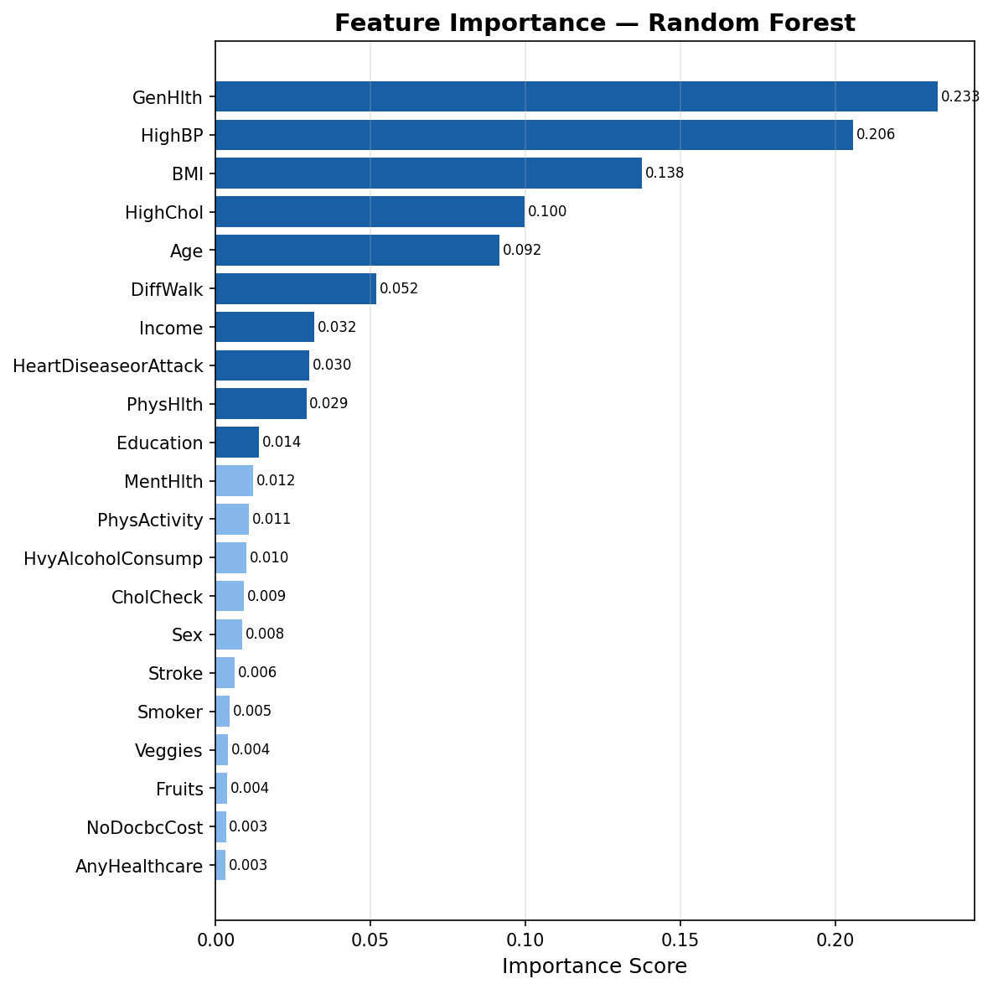
Figure 3: Feature Importance -higher score means stronger influence on prediction

Key observations from the feature importance analysis:
- GenHlth (General Health) is the strongest predictor of diabetes risk
- BMI (Body Mass Index) is the second most important feature
- Age, HighBP (High Blood Pressure), and PhysHlth are also highly influential
- Lifestyle factors like PhysActivity and Fruits contribute moderate importance

5. Evaluation Metrics & Results
The model was evaluated on the 20% held-out test set containing 14,139 samples that were never seen during training. Five standard classification metrics were used to assess performance comprehensively.

5.1 Performance Metrics Explained
Metric | Formula | What it measures
Accuracy | (TP + TN) / (TP + TN + FP + FN) | Overall percentage of correct predictions
Precision | TP / (TP + FP) | Of all predicted Diabetic, how many were actually Diabetic
Recall | TP / (TP + FN) | Of all actual Diabetic cases, how many were correctly found
F1-Score | 2 × (Precision × Recall) / (Precision + Recall) | Harmonic mean balance between Precision and Recall
ROC-AUC | Area under the ROC curve | Model's ability to distinguish between both classes (1.0 = perfect)

5.2 Model Results
The following results were obtained after evaluating the Random Forest Classifier on the test set:
Metric | Score
Accuracy | 74.84%
Precision | 72.82%
Recall | 79.28%
F1-Score | 75.91%
ROC-AUC | 0.8268

5.3 Classification Report
Class | Precision | Recall | F1-Score | Support
Non-Diabetic (0) | 77% | 70% | 74% | 7,070
Diabetic (1) | 73% | 79% | 76% | 7,069
Macro Average | 75% | 75% | 75% | 14,139

5.4 Confusion Matrix
The confusion matrix shows the correct and incorrect predictions across both classes:

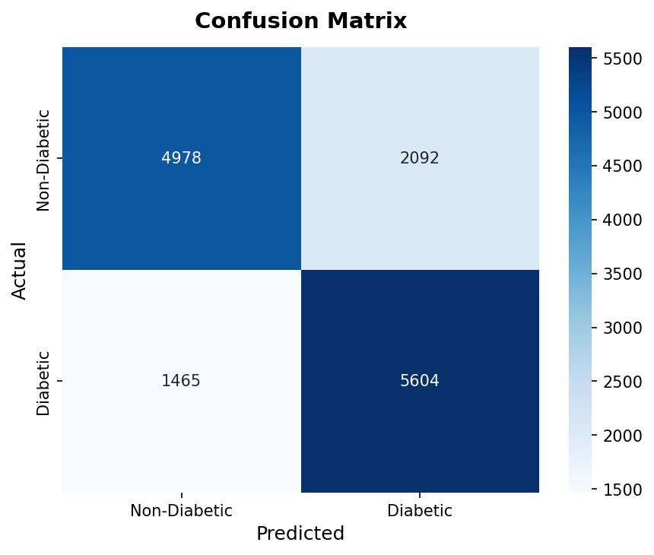
Figure 4: Confusion Matrix - rows = Actual class, columns = Predicted class

Interpretation:
- True Negatives (TN): Non-Diabetic patients correctly classified as Non-Diabetic
- True Positives (TP): Diabetic patients correctly classified as Diabetic
- False Positives (FP): Non-Diabetic patients incorrectly classified as Diabetic
- False Negatives (FN): Diabetic patients missed - classified as Non-Diabetic

In a medical application, minimising False Negatives (FN) is critical -missing a diabetic patient is more harmful than a false alarm. The model achieves a Recall of 79.28%, meaning it correctly identifies approximately 4 out of every 5 diabetic patients.

5.5 ROC-AUC Curve
The Receiver Operating Characteristic (ROC) curve is a graphical plot that illustrates the diagnostic ability of the classifier as its decision threshold is varied. The x-axis represents the False Positive Rate and the y-axis represents the True Positive Rate (Recall). The ideal classifier would produce a curve that hugs the top-left corner of the graph.
The Area Under the Curve (AUC) summarises the entire ROC curve as a single number. A value of 1.0 represents a perfect classifier, while 0.5 represents a model no better than random guessing. Our model achieves an AUC of 0.8268, which is considered a strong result and indicates the model has good discriminative power.
- AUC = 1.0 - Perfect classifier
- AUC = 0.5 - Random classifier
- Our model AUC = 0.8268 - Strong classifier

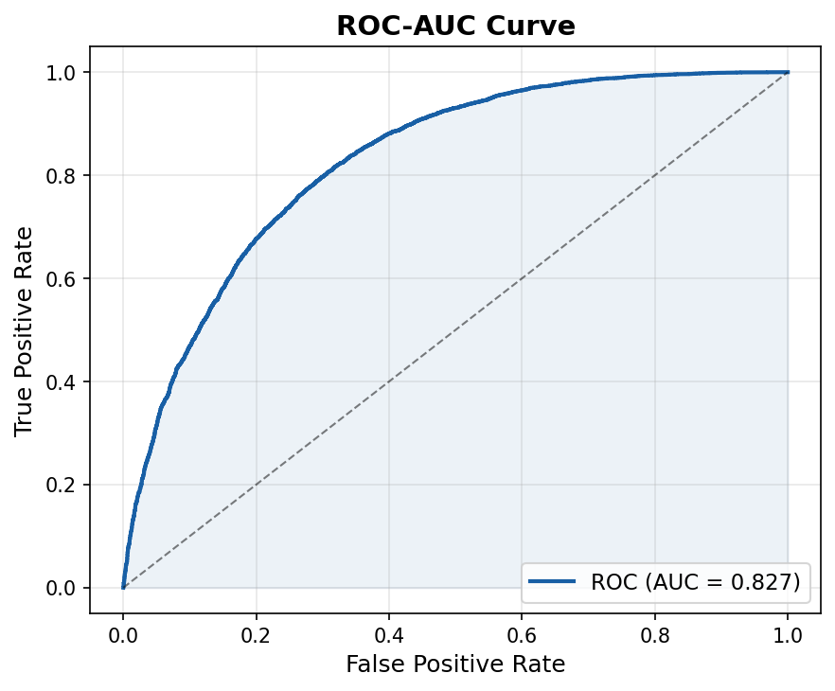
Figure 5: ROC-AUC Curve - AUC = 0.8268 indicates strong discriminative ability

6. Conclusion
The AI-Based Diabetes Prediction System successfully demonstrates the application of supervised machine learning in the healthcare domain. The Random Forest Classifier trained on the CDC BRFSS 2015 dataset achieved strong and reliable performance across all evaluation metrics.

Key Achievement | Result
Model Accuracy | 74.84% on held-out test set
ROC-AUC Score | 0.8268 - strong discriminative power
Recall | 79.28% - correctly identifies most diabetic patients
Dataset Quality | 70,692 samples, zero missing values, balanced classes
Interactive App | Streamlit web app with real-time predictions
Visualisations | 5 professional charts generated and embedded

This project successfully demonstrates the application of supervised machine learning techniques to a real-world healthcare problem. The complete pipeline from raw CSV data through preprocessing, model training, evaluation, and deployment as a Streamlit web application was implemented from scratch and documented thoroughly. The interactive application allows any user to enter their health details and receive an immediate risk assessment along with personalised health recommendations.
Produced comprehensive visualisations including confusion matrix, ROC curve, feature importance, and correlation heatmap.The interactive prediction interface is build through streamlit and can now view Streamlit app in your browser.
- Local URL: http://localhost:8501, Network URL: http://127.0.0.1:8501

